**F. Y. B. Tech Academic Year 2021-22**

**Subject:** Programming and Problem Solving **Trimester:** 2

**Name:** Shreerang Mhatre  **Division:** 11

**Roll No:** 111056  **Batch:** K3

ASSIGNMENT NO: 3

**AIM:** Write a menu driven program in C to implement the basic arithmetic

operations.

**OBJECTIVE:**

1. To learn and understand operators in C

2. To learn and understand switch case statement.

**THEORY:**

Arithmetic, Logical and relational operators.

Switch case – Use, syntax, example

**Platform:** 64 –bit Windows 10

**Technology:** Open Source Visual Studio Code

**Algorithm:**

**Step1)** Start

**Step2)** Enter the first number

**Step3)** Enter the Second number

**Step4)** The Main Menu is displayed

**Step5)** Enter your Choice for

[1] Addition

[2] Subtraction

[3] Multiplication

[4] Division

[5] Exit

**Step6)** The output for selected menu is displayed

**Step7)** Goto Step2) to select different Menu ; Else Exit

**Step8)** Stop

**Flowchart:**

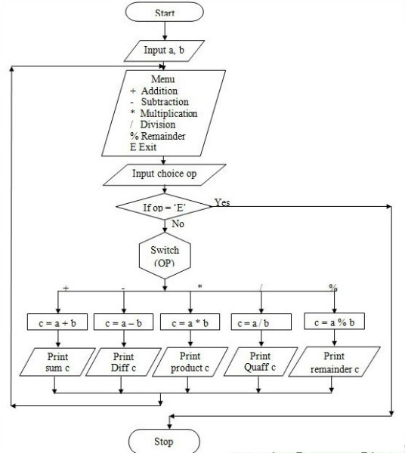

**Visual Studio Code :**

**Code for given program:**

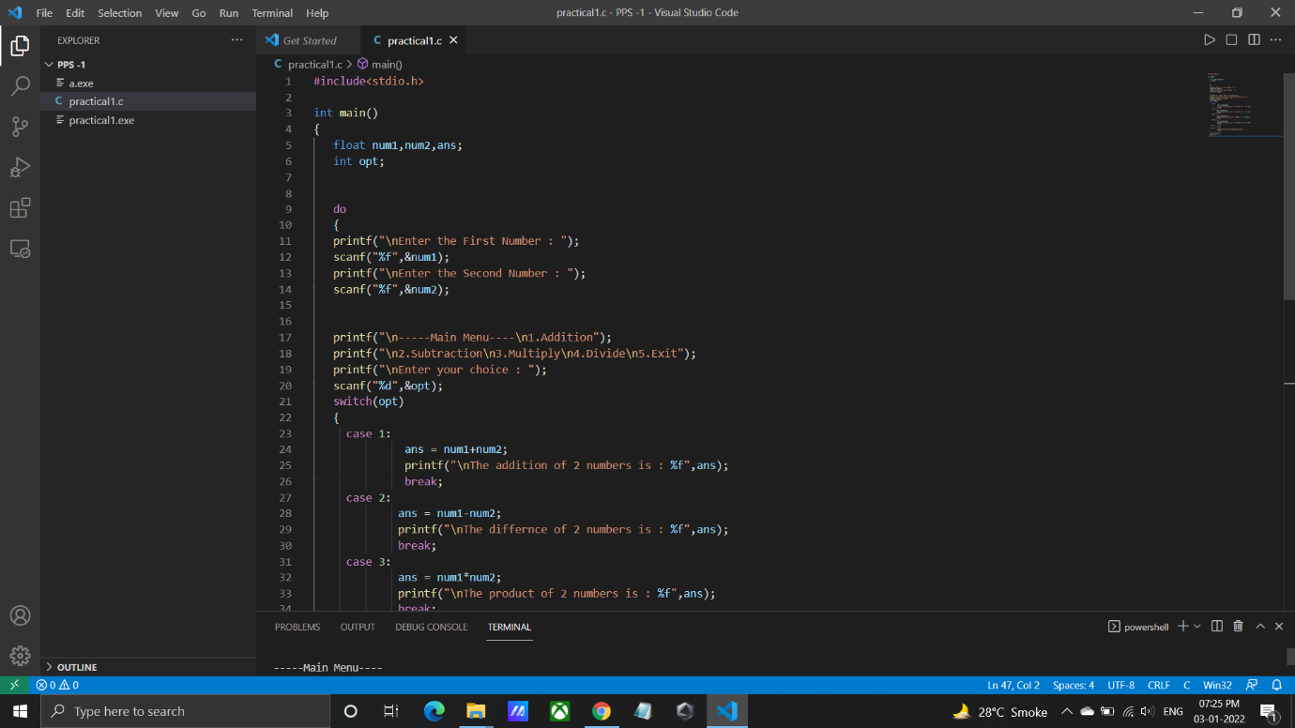

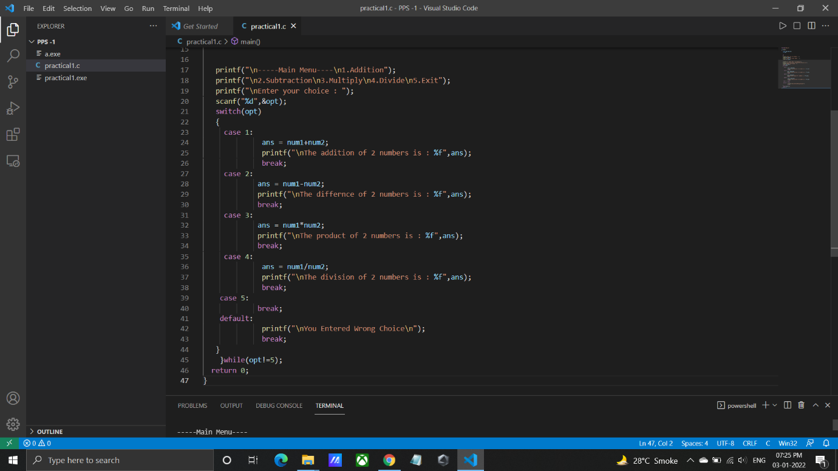

**Output for given program:**

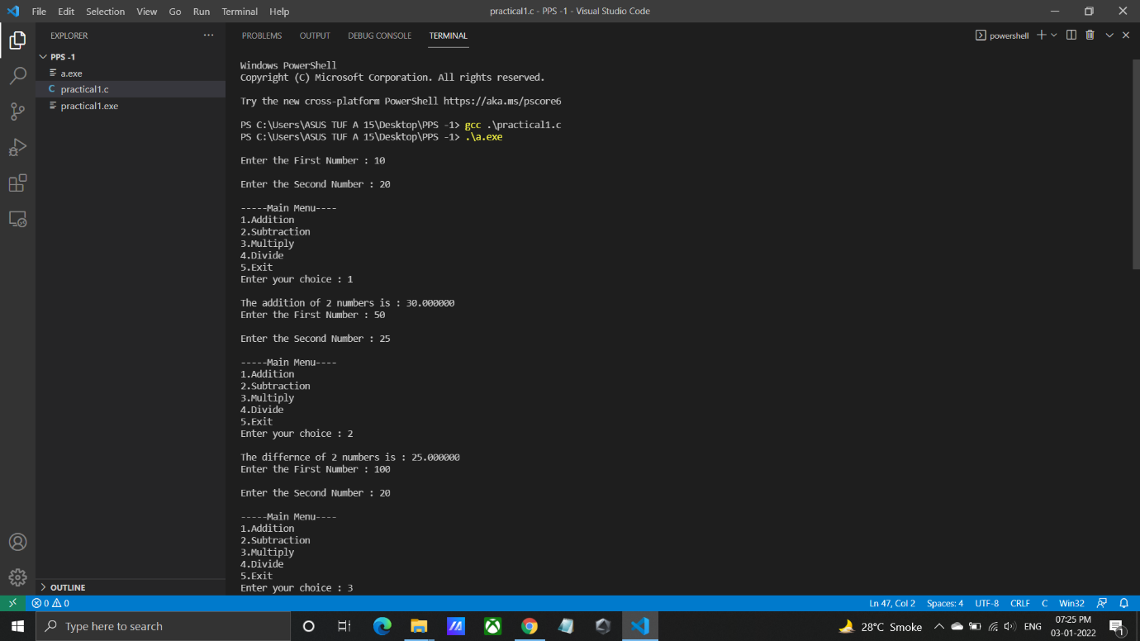

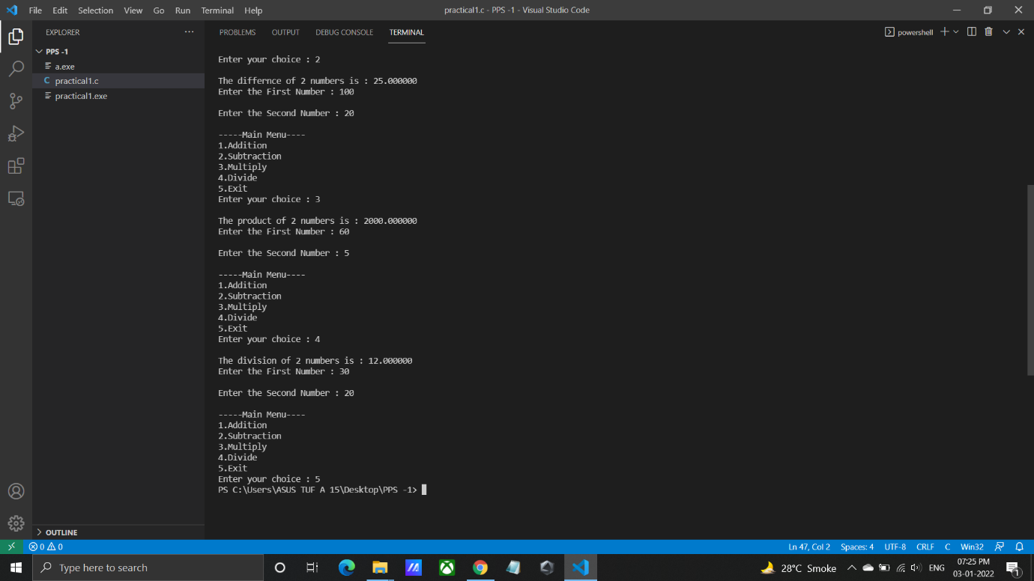

**INPUT**: Any 2 numbers , and choice for operation to be performed.

**OUTPUT: if choice is 1:** Addition is=30

**if choice is 2:** Subtraction is=25

**if choice is 3:** Multiplication=2000

**if choice is 4:** Division=12

**CONCLUSION:** Thus implemented the basic arithmetic calculator using switch

case statement.

**FAQ:**

1. What is break statement?

ANS: Break Statement is a loop control statement that is used to terminate the loop. As soon as the break statement is encountered from within a loop, the loop iterations stop there, and control returns from the loop immediately to the first statement after the loop

1. Does case is the keyword?

ANS: Yes case is a keyword in c language.

1. Why to write default case?

ANS: A switch statement can have an optional default case, which must appear at the end of the switch. The default case can be used for performing a task when none of the cases is true. No break is needed in the default case.